**Adaptive LUT-based Variable On-time Control for**

**CRM Boost PFC Converters**

**Abstract**

This paper proposes an adaptive look-up-table (LUT)-based variable on-time (VOT) control for CRM boost PFC converters, which combines advantages of conventional LUT method and real-time calculation method. By the numerical fitting method, the approximate functional form of the on-time is derived, which is related to both the input voltage and load. The mapping relationships of VOT tables under different load and input RMS voltage are investigated. Based on the mapping relationships, only one VOT table is required to be preloaded in LUT. The adaptability of the proposed control is conveniently realized within the universal AC input and entire load range through the inherent voltage loop and a simple linear calculation. With the proposed control, the required memory space for VOT tables is effectively reduced and the computation time is significantly shortened, leading to a low system cost. Moreover, compared with the constant on-time (COT) control and other VOT controls, the proposed control can further suppress the input current distortion.

*Index Terms*--- Variable on-time (VOT), critical mode (CRM),boost power factor corrector (PFC), look-up-table (LUT),adaptive control, input current distortion, numerical fitting, mapping relationship.

**EXISTING SYSTEM**

Power factor correction (PFC) is required for ac-dc power conversion to achieve low total harmonics distortion (THD) and high power factor (PF). Boost converters are often employed to implement active PFC technique [1]-[4]. Thanks to the simple control and low switching loss, critical conduction mode (CRM) boost PFC converters are widely used in low-to-medium power applications [5]-[9]. For CRM boost PFC converters, due to the resonance between the boost inductor and parasitic capacitances of power devices after the demagnetization of the boost inductor, zero-voltage switching (ZVS) or valley switching (VS) for the power switch is achieved. During the resonance, the boost inductor remains a negative current to discharge the output junction capacitance of the power switch, which results in the input current distortion especially near the zero-crossing input voltage In order to suppress the input current distortion caused by the negative inductor current, many variable on-time (VOT)controls are developed. VOT controls eliminate the effect of negative inductor current by building up more positive inductor current. The input current distortion is essentially related to both the input voltage and load, thus VOT is supposed to be a function of the input voltage and load theoretically.

**EXISTING SYSTEM DISADVANTAGES**

* Many analog controllers only sense the input voltage to generate additional on-time and ignore the load effect.
* The on-time is compensated by the peak switch current but the influence of instantaneous input voltage is ignored.
* The analog-based VOT controls in cannot provide accurate VOT control, so the trail-and-error design is normally accepted to optimize THD, causing difficulties in the design procedure.
* The average current mode (ACM) control is introduced to compensate the input current distortion.
* The additional current control loop and sampling for the average inductor current complicate the circuit implementation.

**PROPOSED SYSTEM**

The quantitative relation among the on-time, input voltage and load is complicated, the flexible digital control is necessary. The digital-based VOT controls are classified into two categories. One is the real-time calculation method, and the other is the look-up table (LUT) method. The real-time calculation method needs massive online calculation and requires a high-end MCU. The LUT method avoids the online calculation by preloading several VOT tables for different input and load, but its adaptability becomes an issue within the universal AC input and entire load range due to the discrete and finite tables. The linear regression is employed to compute the on-time under different load based on finite tables however this method cannot realize the adaptability under different input. This paper proposes an adaptive LUT-based VOT control for CRM boost PFC converters. Based on the functional form of the on-time, the mapping relationships of VOT tables under different load and input RMS voltage are revealed. Based on the mapping relationships, only one VOT table is required in LUT within the universal AC input and entire load range, the adaptability of the proposed control is conveniently realized by the inherent voltage loop and a simple linear calculation. The proposed control significantly suppresses the input current distortion with a reduced system cost.

**BLOCK DIAGRAM**

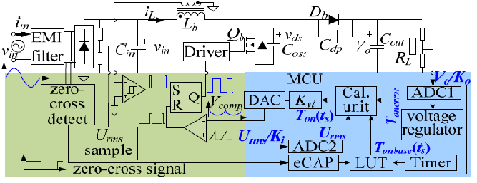

**PROPOSED ADVANTAGE**

* Adaptive LUT-based Method with a Reduced System Cost.
* Improvement of Input Current THD
* The real-time calculation frequency is reduced from the switching frequency to the query frequency.
* Replaces the complex arithmetic calculation in the previous real-time calculation method, so the high speed requirement for MCU is relaxed.